LIDAR Testing 12/16/15

Experiment 1 had the following conditions:

* Physical setup as seen in Figure 1.
* Data recorded in the files seen in Figure 2.
* Lighting was exclusively the lab overhead lighting, but the area was mostly in shade, as seen in Figure 1.
* 10 full scans were recorded. Theta ranges from 0-180 degrees no grouped datapoints, Phi ranges from 0 (vertical) to -90 (horizontal) and changes in 10 degree increments.

Experiment 2 had the following conditions:

* Physical layout as seen in Figure 3.
* Data stored in files shown in Figure 4.
* Lighting is the same as in experiment 1, except the scan area is not in shadow.
* 10 full scans were recorded, using the same variables as in experiment 1.

Experiment 3 had the following conditions:

* Experiment conditions were the same as experiment 2, except LIDAR scanner was raised an additional 267mm off the floor.
* Data recorded in the files shown in figure 5.

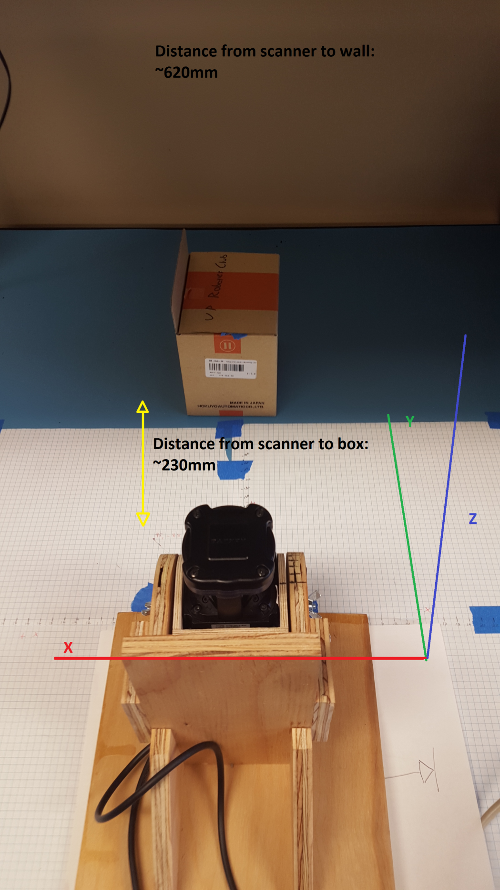

Figure – experiment 1 setup

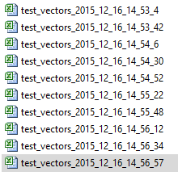

Figure – experiment 1 files

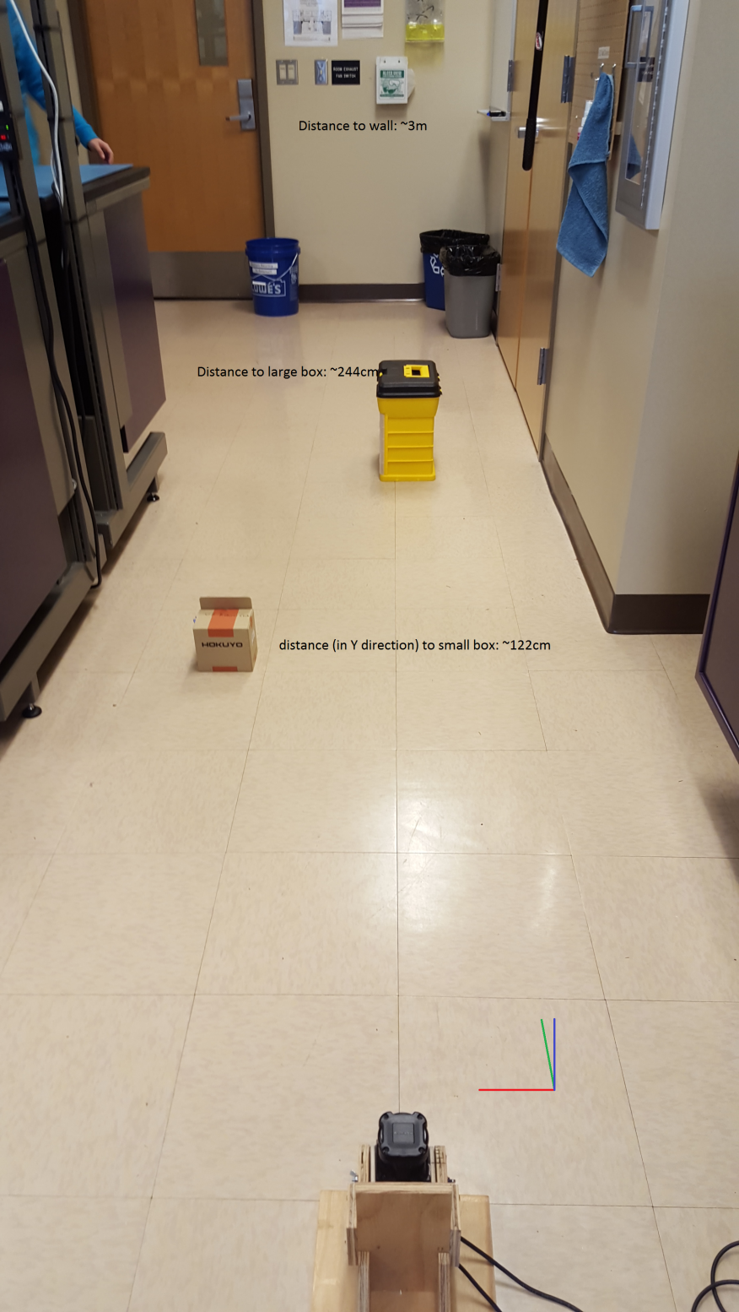

Figure – experiment 2 setup

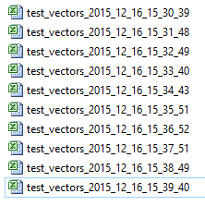

Figure – experiment 2 files

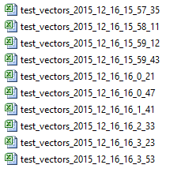

Figure – experiment 3 files